PS 261Class 5-408

Help us Stop ANIMAL TESTING Now!!

DID YOU KNOW….?

- Every year, more than 100 million animals are burned, crippled, poisoned, and abused in U.S. labs.

- Products that you use every day- your soap, your shampoo, your toothpaste- were probably tested on animals.

- In some countries, it is against the law to test cosmetic products on animals.

- We don’t have to abuse and kill animals to create new products- there are alternatives!

- There is a lot you can do to help prevent animal testing!
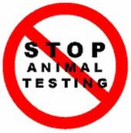

Q. What is animal testing?

A. When companies test chemicals and other ingredients on animals to see if they are safe for humans.

Q. What do labs do to animals when they are testing new ingredients?

A. Labs put the animals to sleep and inject them with chemicals. Many of the chemicals cause terrible suffering and many animals die. Examples of abuse are being infected with diseases or poisons, skin being burned, eyes being blinded, and being deprived of food and water.
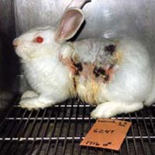

Q. What happens to animals after the testing?

A. They are used for another test or killed.

Q. Does animal testing work? Is it a reliable way to find out how a person would react to a product?

A. It is not reliable because animals do not have the same anatomy as humans. Their bodies react differently than humans. The side effects that animals have can be very different from the side effects that humans have.

Q. How can I figure out which products I use have been tested on animals?

A. Look at the product packaging. Look for the bunny symbol or for words that say the company does not test on animals. Use the internet to find out if the company uses animal testing. Click on www. features.peta.org/cruelty-free-company-search/index.aspx.
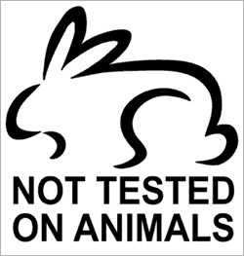

Q. Are there alternatives to animal testing? If so, what are they?

A. Yes.

Many ingredients have already been tested and companies can use these ingredients.

If companies want to use new ingredients that need to be tested, they can use tests that don’t use animals. They can use human cells, human volunteers, or computer models.

THREE THINGS YOU CAN DO TO HELP

- Take our cruelty-free pledge

I promise to never buy a product that has been tested on animals. I will check every product I buy for the bunny symbol or for other information that tells me it has not been tested on animals.

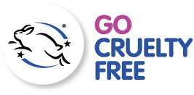
2. Write a letter of complaint to a company that uses animal testing

- Find a product that you use every day that has been tested on animals.

- Find the address of the company that makes the product, look on the package or on the internet

- Send the letter to the President of the company

- Tell the President how upset you are that the company uses animal testing

- Tell the President that you will stop using this product and that you will tell your friends to stop using their product

- Ask the President to stop using animal testing and to find an alternative method for his company to make new products

- You could also send back the product and ask for a refund

3. Sign our petition

Here is what our petition says:

Every year, more than 100 million animals are burned, crippled,
poisoned, and abused in U.S. labs. We support the Humane
Cosmetics Act. By signing this petition, we are asking Congress
to ban all animal testing on cosmetic products in the United States.

If you don’t see us walking around the school with our petition, come to the library to sign it!! We are going to send the signatures to our NY representatives in Congress and ask them to help pass the Humane Cosmetics Act.

